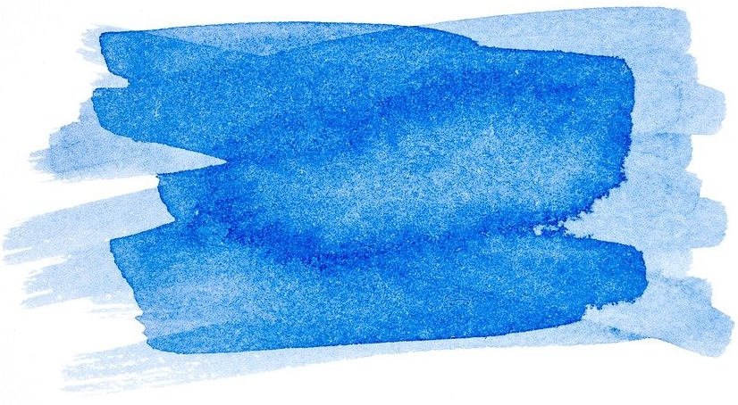
Exercise 3 Stop and think -. Women's rights and concerns
QUESTION - Stop and think:
What rights did women demand back then? Can you imagine why?
……………………………………………………………………………………………………………………………………………………………………………………………………………………………………………………………………………………………………………………………………………………………………………………………………………………………………………………………………………………………………………………………………………………………………………………………………………………………………………………..
How is it today? Are there still demands/issues today that are of urgent concern to women?
……………………………………………………………………………………………………………………………………………………………………………………………………………………………………………………………………………………………………………………………………………………………………………………………………………………………………………………………………………………………………………………………………………………………………………………………………………………………………………………..

