**How to prepare the ACT-Game Materials**

You can find all the copy templates on the [European Heart website](https://european-heart.eu/products/). Scroll down the page  
 until you come to the ACT Game and click on the button.

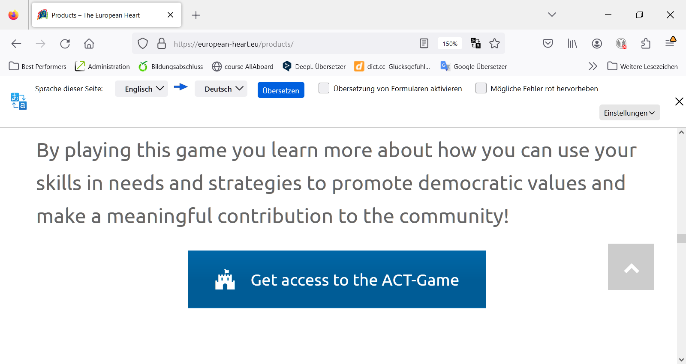

Here you will find a separate folder for each of the 4 levels with the materials you need.

You can print out all the materials yourself or commission a print shop. Please note the following instructions:

**Playing cards** (location-, person-, topic- and condition- cards)

Printing templates are available for business card printing and self-cutting.

**Business card printing:** Get business card board that can be ***printed on both sides*** in ***85x54cm format (standard format).*** Select the type ***"Smooth edges"***. Print the file with the name "...Cards_Businesscards-Print_8.pdf." on it.

**Self-cut:** Print the file "...Cards template for cutting to size" on thick A4 paper of higher quality (from 250g/m2). You can also use coloured copy cardboard. Then cut the cards along the black lines with a cutting machine.

**Avatar and Superpower Cards**

These are best printed on glossy A4 photo paper so they look really good.

The superpower cards are folded in half and placed on the table in front of the players, so you should print these on thicker paper or card if photo paper is not available.

**Game boards**

There are printing templates available for self-printing and for commissioning a printing company.

**Self-printing:** Print the file on thicker A4 paper (preferably 250g/m2). The game boards 1, 3 and 4 must be able to be written on, game board 2 can be used again and again (can also be printed on photo paper).

**Commissioning a print shop:** For professional printing, select the file "BOARD ... with margin". When placing your order, specify that game boards 1, 3 and 4 must be able to be written on. Bear in mind, however, that these three game boards can only be used once. It would probably only be worth ordering larger quantities.

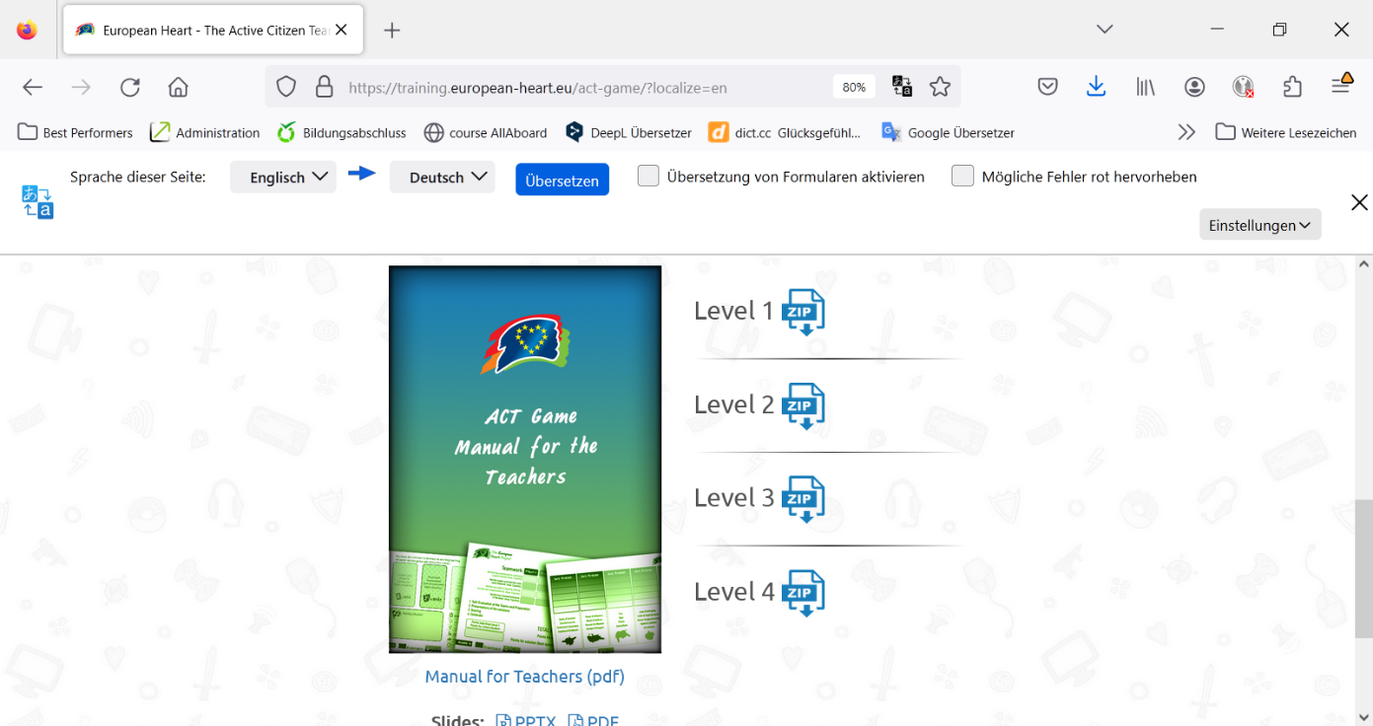**Manuals**

You will need one "Manual for Teachers" for yourself. You will find it on the left next to the individual levels. Click on the picture to download and print the booklet in A4 format.

For Level 3, each pupil team needs an "Instruction for Superheroes". You can find this as a PDF in the Level 3 folder.

Overview of the materials needed

For yourself, you will need a " Manual for Teachers ". There is also a PPT available that you can use to explain the game to your pupils. You can download it from the website below the teacher's guide.

Level 1:

*For each team one Gameboard 1*

*1-2 Sets of Person-Cards*

*1-2 Sets of Location-Cards*

*1-2 Sets of Topic Cards*

Level 2

*For each team one Gameboard 2*

*For each team one Set of Condition-Cards*

*For each team one Set of Avatar-Cards*

*For each team one Set of Superpower-Cards*

Level 3

*For each team one Gameboard 3*

*For each team one Set of Superpower-Cards (from Level 2)*

*For each team one manual* *„Instruktions for Superheroes”*

Level 4

*For each team one Gameboard 4*

**Recommended Printshops**