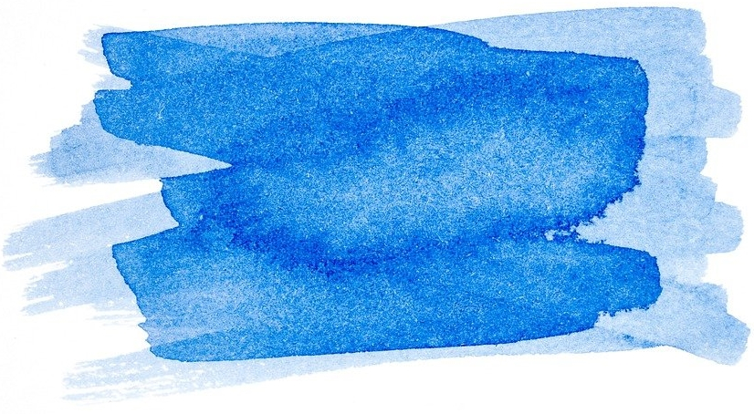

Exercise 3 Stop and think -. Women's rights and concerns

|  |
| --- |
| **QUESTION - Stop and think:**  *What rights did women demand back then? Can you imagine why?* |
| …………………………………………………………………………………………………………………………………………………………………………………………………………………………………………………………………………………………………………………………………………………………………………………………………………………………………………………………………………………………………………………………………………………………………………………………………………………………………………………….. |
| *How is it today? Are there still demands/issues today that are of urgent concern to women?* |
| …………………………………………………………………………………………………………………………………………………………………………………………………………………………………………………………………………………………………………………………………………………………………………………………………………………………………………………………………………………………………………………………………………………………………………………………………………………………………………………….. |